Spectral coherence: GBPUSD and EURGBP
Method 21 / daily log returns / Welch magnitude-squared coherence / Alpari D1 full available history

Study setup
Logical pair: GBPUSD , EURGBP
Broker symbols: GBPUSD_i , EURGBP_i
Snapshot: 2026-11-03_majors_alpari_D1
Timeframe: D1
Matched return window: 1999-01-06 to 2026-11-02 (UTC bar dates)
Matched return count n: 7199
Dropped unfinished last bar dated 2026-11-03 UTC after a tick-volume check against the prior complete day.
Welch: fs=1.0, nperseg=256, noverlap=128, window=hann, detrend=constant
Headline: gamma^2 nearest f=1/5; also 1/21 and 1/63
Complete matched rows (Excel): GBPUSD-EURGBP_Spectral_D1.xlsx
Complete matched rows (HTML table): GBPUSD-EURGBP_Spectral_D1_data.html

Method carried forward
Magnitude-squared spectral coherence gamma^2(f) measures shared linear power between matched daily log returns of close, ln(close_t / close_t-1), at each frequency f (cycles per day). Quotes are not inverted. Welch settings are frozen: fs=1, nperseg=256, noverlap=128, window=hann, detrend=constant. Headline is gamma^2 at the frequency bin nearest f=1/5 (five-day cycle from the formula sheet). Also reported: gamma^2 nearest f=1/21 and f=1/63, mean gamma^2 over the frequency grid, and phase of the cross-spectrum at the 1/5 bin. Coherence is unsigned (0 to 1); phase carries timing. Same-sample Pearson r is a side check only. This is not causation and not a trading signal.

Results (headline)
gamma^2 near 1/5: 0.373158
bin f (1/5): 0.199219
phase at 1/5 (rad): -2.946494
gamma^2 near 1/21: 0.130619
gamma^2 near 1/63: 0.184809
mean gamma^2: 0.178790
Pearson r: -0.397845

Target-frequency summary
period | target_f | f_bin | gamma2 | phase_rad
5 | 0.2 | 0.19921875 | 0.37315829 | -2.946494
21 | 0.04761905 | 0.046875 | 0.13061947 | 2.9815999
63 | 0.01587302 | 0.015625 | 0.18480911 | 2.733958

Conclusion
Headline gamma^2 near f=1/5 for GBPUSD and EURGBP: 0.3732 (bin f=0.199219, phase=-2.9465 rad). At ~1/21: 0.1306; at ~1/63: 0.1848. Mean gamma^2 = 0.1788. Pearson r = -0.3978. This is frequency-domain linkage, not a trading signal.

Charts
Daily closes

Daily log returns

Spectral coherence gamma^2(f)
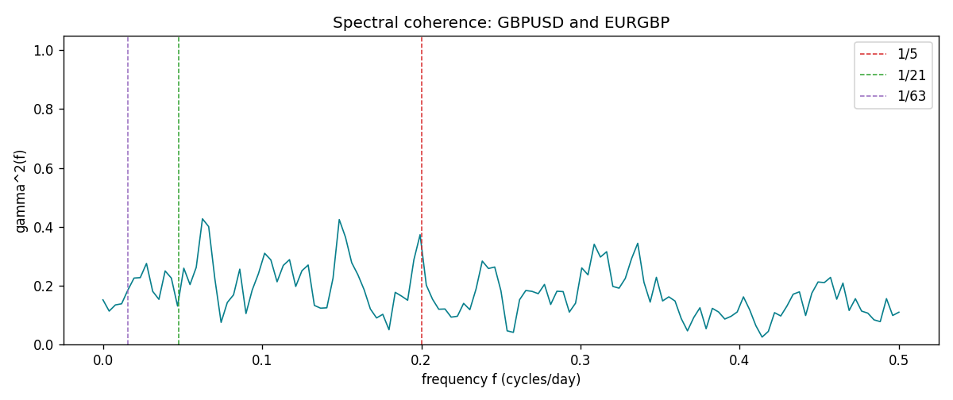

Data report
Matched rows and the coherence sheet are in the sibling Excel workbook named GBPUSD-EURGBP_Spectral_D1.xlsx. Embedding all rows as a Word table is impractical; this file holds column summaries and the first and last 15 matched rows.
Columns: time, GBPUSD_open, EURGBP_open, GBPUSD_high, EURGBP_high, GBPUSD_low, EURGBP_low, GBPUSD_close, EURGBP_close, GBPUSD_tick_volume, EURGBP_tick_volume, GBPUSD_spread, EURGBP_spread, GBPUSD_real_volume, EURGBP_real_volume, GBPUSD_log_return, EURGBP_log_return
Column summaries (matched calculation rows)
column | count | mean | std | min | 25% | 50% | 75% | max
GBPUSD_open | 7199 | 1.5160931 | 0.21831499 | 1.06854 | 1.324955 | 1.5114 | 1.63186 | 2.1066
EURGBP_open | 7199 | 0.78665041 | 0.09676322 | 0.5734 | 0.6873 | 0.83367 | 0.865175 | 0.9769
GBPUSD_high | 7199 | 1.5223838 | 0.21887686 | 1.08366 | 1.32978 | 1.5181 | 1.6384 | 2.1161
EURGBP_high | 7199 | 0.78972718 | 0.09713886 | 0.5789 | 0.68935 | 0.83657 | 0.86804 | 0.9799
GBPUSD_low | 7199 | 1.5097628 | 0.21753729 | 1.03518 | 1.3194 | 1.50323 | 1.62442 | 2.0983
EURGBP_low | 7199 | 0.78395066 | 0.09658082 | 0.5682 | 0.6853 | 0.83147 | 0.862765 | 0.9661
GBPUSD_close | 7199 | 1.5161471 | 0.21826306 | 1.06879 | 1.325055 | 1.51122 | 1.63216 | 2.1065
EURGBP_close | 7199 | 0.78669405 | 0.09676312 | 0.5735 | 0.6875 | 0.8337 | 0.86528 | 0.977
GBPUSD_tick_volume | 7199 | 94850.986 | 153561.38 | 62 | 9998.5 | 52911 | 91818.5 | 1273370
EURGBP_tick_volume | 7199 | 86949.029 | 145390.09 | 154 | 6517.5 | 44265 | 81326 | 1424684
GBPUSD_spread | 7199 | 26.96055 | 19.19062 | 0 | 11 | 20 | 50 | 50
EURGBP_spread | 7199 | 21.393666 | 19.14328 | 0 | 4 | 13 | 50 | 50
GBPUSD_real_volume | 7199 | 3.5570778e+09 | 8.4449923e+10 | 0 | 0 | 0 | 0 | 2.4038164e+12
EURGBP_real_volume | 7199 | 2.7805214e+10 | 1.3507095e+11 | 0 | 0 | 0 | 0 | 3.5726265e+12
GBPUSD_log_return | 7199 | -3.133e-05 | 0.00564236 | -0.08388241 | -0.00313644 | 2.978e-05 | 0.00317207 | 0.03112653
EURGBP_log_return | 7199 | 2.179e-05 | 0.00487166 | -0.03067367 | -0.0026225 | -0.00010035 | 0.00256076 | 0.06075387
First 15 matched rows (selected columns)
time | GBPUSD_log_return | EURGBP_log_return
1999-01-06 | -0.00060452184 | -0.013303338
1999-01-07 | -0.002118709 | 0.011051402
1999-01-08 | -0.0058954193 | -0.004943862
1999-01-11 | -0.0056851331 | -0.0012752393
1999-01-12 | 0.0022657001 | 0.0033970309
1999-01-13 | 0.0091330396 | 0.00042381861
1999-01-14 | 0.0019376331 | -0.0019793588
1999-01-15 | -0.0017558204 | -0.0076715819
1999-01-18 | 0.0012112405 | 0.00071280921
1999-01-19 | 0.0018745281 | -0.0014261269
1999-01-20 | -0.0049053846 | 0.0019960086
1999-01-21 | 0.0031518998 | -0.00071240297
1999-01-22 | 0.0024781662 | -0.0017118406
1999-01-25 | 0.0012066366 | -0.0054402425
1999-01-26 | 0.00072328374 | -0.00057438255
Last 15 matched rows (selected columns)
time | GBPUSD_log_return | EURGBP_log_return
2026-10-13 | 0.0036434319 | 0.00020130374
2026-10-14 | -0.0049164679 | 0.0011241873
2026-10-15 | 0.0065976411 | -0.00087557391
2026-10-16 | 0.0037592051 | -0.0020380844
2026-10-19 | -0.0017500314 | -0.00056950988
2026-10-20 | 0.0055923442 | -0.0035906254
2026-10-21 | 0.0012476328 | -0.00140647
2026-10-22 | 0.00022396082 | -0.0018743924
2026-10-23 | -0.0021146949 | 0.00082421033
2026-10-26 | -0.0024340661 | 0.00013133309
2026-10-27 | -0.0023648393 | -0.0019957343
2026-10-28 | 0.0015771808 | 0.00066967224
2026-10-29 | 0.0035881935 | -0.0011722209
2026-10-30 | 0.0013450605 | -0.0024205543
2026-11-02 | 0.0010971256 | 0.00089940465
First 15 frequency bins
f | gamma2 | phase_rad | period_days
0 | 0.15180689 | 3.1415927 | inf
0.00390625 | 0.11349253 | 2.6993365 | 256
0.0078125 | 0.13450481 | 2.4000526 | 128
0.01171875 | 0.13839087 | 2.4222741 | 85.333333
0.015625 | 0.18480911 | 2.733958 | 64
0.01953125 | 0.2257897 | -3.0730198 | 51.2
0.0234375 | 0.22726847 | 2.8780174 | 42.666667
0.02734375 | 0.27546602 | 2.846295 | 36.571429
0.03125 | 0.1805586 | 2.9077239 | 32
0.03515625 | 0.15349355 | 2.4695411 | 28.444444
0.0390625 | 0.25005347 | 2.6451933 | 25.6
0.04296875 | 0.2255578 | 2.6826158 | 23.272727
0.046875 | 0.13061947 | 2.9815999 | 21.333333
0.05078125 | 0.25936113 | -2.9788732 | 19.692308
0.0546875 | 0.2036392 | 3.1341105 | 18.285714

